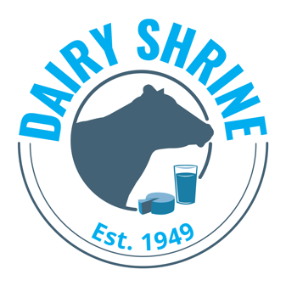

Dairy Shrine Student Social Media Committee
Goals and Application

Honor past and present dairy leaders. Inspire future dairy leaders.
Record dairy industry history. Promote the dairy industry

COMMITTEE GOALS
- To effectively promote the mission of the National Dairy Shrine via social media platforms through inspiring the future of the industry, honoring its past and preserving its rich history.
- To share a diverse array of content through human interest stories, dairy industry news, organization news and award recipients as well as
- membership benefits.
- To collaborate with other dairy industry organizations and checkoff programs to promote the dairy industry and increase consumer
- engagement.
- To make current and potential members of the National Dairy Shrine aware of award recognition opportunities, scholarship and internship
- opportunities and sponsorship opportunities related to the organization. To equip student members of the committee with necessary skills towards a future career in the dairy, communications and marketing industries.

All Applications are due April 15 at midnight (CST) each year.

Instructions for applying:

- Download this application and type in your responses. Save the file as DSSocialMediaCommittee.LastName.FirstName.doc. Email to info@dairyshrine.org by April 15th of each year. If you have problems, please e-mail Dairy Shrine.

Applicants will receive a confirmation email after April 15th
about their submission of the application form.

Dairy Shrine Student Social Media Committee Goals and Application– page 2

I. Personal Data
Last Name First Name Middle Initial
Applicant

College/University College Graduation Date (if applicable)

Year in School Grade Point Average Major Interest

Complete Home Address

( ) ( )
Home Phone Number Cell Phone Number

Email Address

II. Classes taken related to marketing, dairy promotion, milk or dairy product communications or other dairy industry-related subjects:

III. Future Career Goals (300 words or less):

Dairy Shrine Student Social Media Committee Goals and Application– page 2

IV. Briefly outline your dairy and non-dairy related extracurricular involvement and leadership experiences:

V. What experiences have you had using social media to promote an organization or reinforce branding efforts? (300 words or less)

VI. Please provide an example of a time you advocated for the dairy industry, whether through social media or a different platform. (300 words or less)

