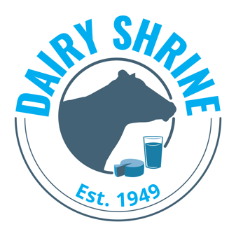

Senior Dairy Student Recognition Award Program Application

The Senior Student Recognition Program recognizes graduating four-year college seniors planning a career related to dairy (production agriculture, manufacturing, marketing, agricultural law, business, communications, veterinary medicine, research and environmental sciences) who have demonstrated leadership skills, academic ability, and interest in dairy cattle.

Only two applicants per college or university are accepted for this contest in any given year. The total number of awards will be determined by the number and quality of applicants. The Top student will receive $2000, the second $1500 and additional $1000 scholarships will be awarded with the total being determined by the number and quality of applications and available funding.

Please note that a student may win this award only once.

Scholarship recipients will be recognized at the Dairy Shrine Awards Banquet.
Application/Letter of Recommendation/Transcripts are accepted from March 1, until April 15, midnight, CST.

Instructions for applying:

- Please review all of the requirements listed on the scholarship section at www.dairyshrine.org
- Download this application and type in your responses. Save the file as Senior.Last Name.First Name.doc. Email to info@dairyshrine.org. If you have problems please e-mail Dairy Shrine.
- Send one letter of recommendation from the department chair or a faculty member who is familiar with the applicant’s activities and academic achievements. Please have letter emailed to info@dairyshrine.org.
- Mail an official transcript showing all college courses to be viewed only by the Dairy Shrine Executive Director.

Dairy Shrine Senior Dairy Student Recognition Award Application – Page 2
I. Personal Data

Applicant
Last Name First Name Middle Initial

College/University:

Major:

Complete Home Address:

Home Phone Number: ( ) Cell Phone Number: ( )

Email Address:

College Graduation Date (accomplished or projected)

II. Academic Standing

- College overall grade point average: based on a point scale

- College credits earned for B.S. degree

- List the title, credits, & grades of courses taken related to the dairy industry, dairy production, dairy nutrition, dairy genetics or related fields (Max of 10):

Descriptive Title Credits Grade

Dairy Shrine Senior Dairy Student Recognition Award Application – Page 3
III. Leadership Ability and Extracurricular Activities

- Student Organization / Dairy Club Activities and Offices held in college (10 maximum)

- Dairy Challenge, Dairy Bowl, Dairy Cattle Judging and other student contest activity (10 maximum)

- Other Current Organizational Activities and Office held (10 maximum)

- Honors and Awards received recently (10 maximum

Dairy Shrine Senior Dairy Student Recognition Award Application – Page 4

IV. Describe the specific Activities or Experiences you have sought related to your planned future in the Dairy Industry: (500 words or less)

V. Plans for the Future in the Dairy Industry (500 words or less.)

_________________________________________________________________________________________
Dairy Shrine Board of Directors: Students who are members of Dairy Shrine are eligible to serve on the Board of Directors for Dairy Shrine. A Board term is for 3 years and terms begin at the October Annual Meeting. Please check below if you would be interested in serving a 3-year term on the Dairy Shrine Board of Directors if recommended by the Dairy Shrine Nominating Committee and elected to the Board of Directors at the Dairy Shrine Annual Meeting in October.
____ Yes, I would like the Dairy Shrine Nominating Committee to consider me as a candidate for the Dairy Shrine Board of Directors.

