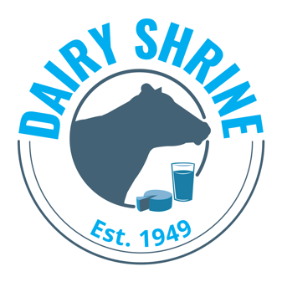

Dairy Shrine Dairy Production Scholarship Application

The Dairy Shrine Dairy Production Scholarship is to encourage qualified undergraduate students to pursue a career related to dairy production agriculture.

The scholarship is available to an undergraduate student currently enrolled in their final year in a two-year college, a certificate program, or a four-year college with an explicit interest in returning to a dairy farm in a management role. Students can receive this scholarship only once.

Applicants must initially be nominated by their advisor. There is no limit to the number of applications from a specific school. In addition to completion of this form, applicants will participate in a video interview to determine the final recipients.

Up to four $2,500 scholarships will be given. Up to two scholarships will be awarded to students in a two-year or certificate program and up to two will be awarded to students in a four-year program. Scholarship recipients will be recognized at the Dairy Shrine Awards Banquet. One of the $2,500 scholarships is provided through a sponsorship from Cargill.

Application/Letter of Recommendation/Transcripts are accepted from
March 1, until April 15, midnight, CST.

Instructions for applying:
- Please review all of the requirements listed on the scholarship section at www.dairyshrine.org
- Download this application and type in your responses. Save the file as Production.Last Name.First Name.doc. Email to info@dairyshrine.org. If you have problems please e-mail Dairy Shrine.
- Send at least one letter of recommendation from a faculty member who is familiar with the applicant’s activities and academic achievements. Please send no more than three. Please have emailed to info@dairyshrine.org.
- Mail an official transcript showing all courses to be viewed only by the Dairy Shrine Executive Director.

Dairy Shrine Dairy Production Scholarship – page 2
I. Personal Data

First Name:

Last Name:

Complete Home Address:

School Email address:

Alternative email address that will be used after graduation:

Cell Phone Number:

Home Phone Number:

College/University/Certificate Program:

Major:

College Graduation Date (accomplished or projected)

Dairy Shrine Dairy Production Scholarship – page 3

II. What led to your interest in pursuing a career in the dairy industry?

III. What have been your experiences working on a dairy farm?

IV. What are your plans after graduation regarding work on a dairy farm? Please emphasize potential management-level opportunities.

Dairy Shrine Dairy Production Scholarship – page 4

V. What motivated you to return to a dairy farm after completion of your studies?

